# FastTrack to Unreal Engine 5

The first notable gaming engine emerged in the 1980s. Bill Budge’s Pinball Construction Set (1983). The Unreal Engine by Epic Games. Types of actors – static actors, dynamic actors, pawns, character actors.

# [youtube.com] How product companies handle production downtime

They use website like ManageEngine.com.



# Digit FastTrack – Android App Development (Foldables Edition)

An app that seamlessly transitions between folded and unfolded states is essential for user satisfaction. Smartphone design moving away from traditional, rigid form factor to a more flexible and adaptable one. Two types – book-style and claimshell-style.

These devices, which can switch between a phone and table-like format, are a promising frontier for developers and designers alike. Users expect between different screen sizes and orientations.

Challenges include handling multiple screen ratios, dealing with screen continuity, and ensuring a seamless transition between folded and unfolded states.

# Digit – October 2023

A subscription-based model for the supposed next iteration of windows a.k.a. windows 12. Linux has only attracted more gamers towards the cult of Linux.

# Digit FastTrack to Notion

Content creation and formatting are the bedrock of Notion.

The database functionalities, interlinked pages, and project management features are realms where Notion outshines.

# Book – Programming Pearls

The programs use a terse coding style: short variable names, few blank lines, and little or no error checking.

A merge sort program reads the file once from the input, sorts it with the aid of work files that are read and written many times, and then writes it once.

Careful analysis of a small problem can sometimes yield tremendous practice benefits.

A designer knows he has arrived at perfection not when there is no longer anything to add, but when there is no longer anything to take away. Simple programs are usually more reliable, secure, robust and efficient than their complex cousins, and easier to build and to maintain.

Good programmers are a little bit lazy: they sit back and wait for an insight rather than rushing forward with their first idea.

Coding skill is just one small part of writing correct programs. The majority of the task is the subject of the tree previous columns: problem definition, algorithm design, and data structure selection. If we perform those tasks well, writing correct code is usually easy.

The first binary search was published in 1946, the first published binary search without bugs did not appear until 1962.

If run time doesn’t matter, linear search is much simpler than binary search; many programmers can get it right on the first try. Because run time is important enough for us to introduce the additional complexity of binary search, we should conduct experiments to ensure that is performance is what we expect.

Rick Lemons said that the best lessor he ever had in debugging was watching a magic show. The magician did a half-dozen impossible tricks, and Lemons found himself tempted to believe them.

Inefficient programs sadden their users with longs waits and missed opportunities.

Everything should be made as simple as possible, but no simpler.

Premature optimization is the root of much programming evil, it can compromise the correctness, functionality and maintainability of programs.

Insertion sort is the method most car players use to sort their cards. Insertion sort is simple to code and may be fast enough for small sorting jobs. For large numbers, run time of Quicksort is crucial.

One part of a programmer’s job is solving today’s problem. Another, and perhaps more important, part of the job is to prepare for solving tomorrow’s problems.

Heapsort never takes more than O(n log n) time to sort and n-element array, and uses just a few words of extra space. The fasters Heapsort is usually slower than the simple Quicksort.

Make it work first before you make it work fast.

Sorting works well for finding the mode, but hashing can be faster.

# HTTP crash course

URL, URI and URN are almost same to get the location address.

Types of headers – X-prefix for headers has been deprecated.

We also have methods like HEAD, TRACE. TRACE is useful to have debugging in case of multiple proxies in-between the communication.

Useful status code –

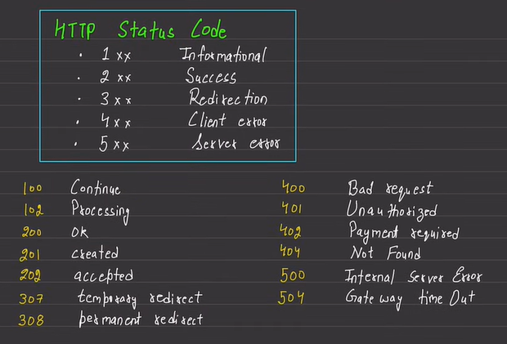

Reverse Proxy – Nginx and caddy are example of reverse proxy servers.

